

AMERICAN INTERNATIONAL UNIVERSITY–BANGLADESH (AIUB)

Faculty of Science and Technology

Department of Computer Science

CSC 3312: SOFTWARE ENGINEERING

Spring 2025-2026

Project Title
A Peer-to-Peer Carpooling Platform for Long-Distance Passengers

Supervised By

Saikat Baul

Submitted By

Group: 04 |  | Section: N
SL | Student Name | Student ID
1. | Atifur Rahaman Shohan | 23-52013-2
2. | Quazi Saad | 23-51964-2
3. | Md. Zahid Hasan | 23-54242-3
4. | Naimur Rahman Kayes | 24-56159-1
5.

Table of Contents

1. INTRODUCTION 3
1.1 Background to the Problem 3
1.2 Selection of Process Model 5
2. SOFTWARE REQUIREMENTS SPECIFICATIONS 8
2.1 User Story Table 8
2.2 Requirements Traceability Matrix 11
2.2.1 Functional Requirements 11
2.2.2 Non-Functional Requirements 15
3. SOFTWARE DESIGN 17
3.1 System Design 17
3.1.1 Use Case Diagram 17
3.1.2 Class Diagram 18
3.2 Wireframe Design 19
4. GIT WORKFLOW 21
5. SOFTWARE TESTING 24
6. CONCLUSION 32

INTRODUCTION

Background to the Problem
Transportation has become a daily necessity for students, employees, and city travelers. Every day, thousands of people travel from one area to another for university, office, business, or personal reasons. However, managing transportation cost and comfort is still a challenge for many people.
Public transportation is usually affordable, but it can be overcrowded, uncomfortable, and time-consuming. During peak hours, it becomes even more difficult to travel smoothly. On the other hand, ride-hailing services offer comfort and convenience, but long-distance rides can be expensive, especially when a single passenger has to pay the full fare alone.
Ride sharing has become a possible solution to reduce transportation costs. However, in many shared ride situations, fare distribution among multiple passengers is not always fully proportional to the actual distance traveled by each passenger. For example, if one passenger travels 15 km, another travels 9 km, and another travels only 3 km within the same shared ride, dividing the fare equally can create dissatisfaction. Short-distance passengers may feel overcharged, while long-distance passengers may question the fairness and transparency of the pricing system.
Currently, people face the following issues:
• High Cost of Single Rides: When one passenger books a full ride for a long distance, the total cost becomes expensive.
• Unfair Equal Fare Division: In many ride-sharing systems, passengers pay equal amounts even if they travel different distances.
• Lack of Transparent Pricing: Passengers often do not clearly understand how the fare is calculated.
• Inefficient Seat Utilization: Many vehicles travel with empty seats while other passengers are searching for affordable rides.
Because of these limitations, there is a strong need for a smarter and more transparent ride-sharing platform that calculates fares proportionally based on the actual distance traveled by each passenger.
Smart-Ride aims to solve this problem by introducing a distance-based fare calculation system within a multi-passenger ride-sharing platform, ensuring fairness, transparency, and cost efficiency.
Target Group of Users
The Smart-Ride system is designed for people who regularly travel within a city or between nearby areas and are looking for a transportation option that is both affordable and fair. The platform mainly focuses on users who want to reduce travel costs while still enjoying comfort and convenience. The main target groups include:
• University Students:
Many students travel daily between their homes and campuses. They often have limited monthly budgets and prefer an option that is more comfortable than crowded public transport but more affordable than booking a full private ride.

• Office Employees:
Working professionals who commute long distances every day spend a significant amount on transportation. They are looking for a practical solution that helps lower daily commuting expenses without compromising reliability and convenience.

• Frequent City Travelers:
Some individuals travel occasionally within the city for business meetings, medical appointments, shopping, or personal reasons. They may not need a private ride every time and would prefer sharing a ride at a reduced cost.

• Ride Sharing Drivers:
Drivers who register on the platform can benefit by carrying multiple passengers traveling in similar directions. This allows them to make better use of available seats and earn fair compensation through a clear and transparent fare calculation system.

Selection of Process Model
Selected Process Model
For the development of the Peer-to-Peer Carpooling Platform for Long-Distance Passengers, the Agile Process Model (Scrum) has been selected as the most suitable model.
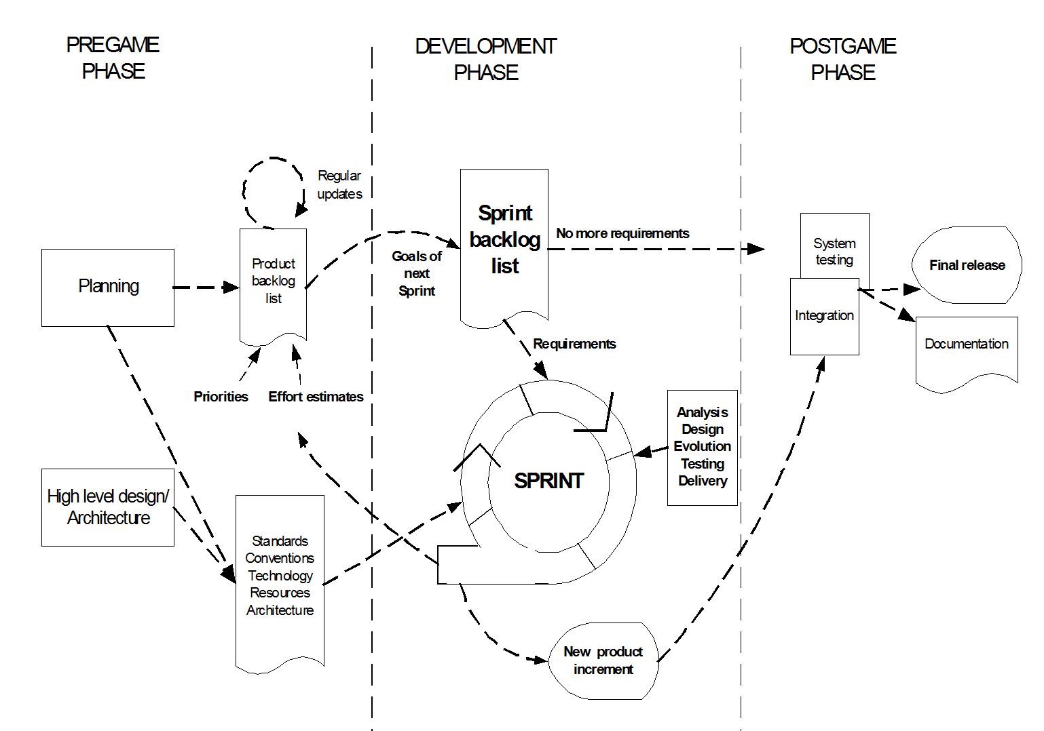
Scrum is an iterative and adaptive method of software development in which the system is created in small steps. It encourages collaboration, continuous improvement, and managing the changing requirements. As our system requires various features, including ride sharing, fare calculation, and real-time tracking, Scrum offers flexibility and a higher level of control over development.
Figure 1: scrum process flow

Description of Scrum Process Model:
According to the Scrum model, the development process is divided into three main phases:
1. Pre-Game Phase
This phase includes planning and architecture design.
- Planning:
The system requirements are identified and listed in the Product Backlog.
System requirements are prioritized, and effort estimation is done.
The backlog is continuously updated as new requirements appear.
- Architecture:
A high-level system design is prepared based on the backlog items.
Design decisions are reviewed before development starts.

2. Game (Development) Phase
This is the main development phase where the system is built.
- Development is done in Sprints
- Each sprint lasts 1 to 4 weeks
- Each sprint includes:
  - Requirement analysis
  - Design
  - Implementation
  - Testing
  - Delivery
Each sprint produces a working part of the system.
3. Post-Game Phase
This phase occurs when development is completed.
- System integration is performed
- Final system testing is done
- Documentation is prepared
- The system is made ready for release
Roles and Responsibilities of Scrum
- Scrum Master:
Ensures that the Scrum process is followed properly and helps the team remove obstacles.
- Product Owner:
Manages the Product Backlog, sets priorities, and makes decisions regarding system features.
- Scrum Team:
Responsible for development tasks such as design, coding, and testing. The team is self-organized.
- Customer:
Provides requirements and feedback on system features.
- Management:
Makes final decisions and ensures standards and goals are maintained.

Why Scrum is Suitable for Our Project
Scrum is appropriate to this project since the system is user-based and feature-rich, and the requirements can vary along the way. It enables the system to be built in phases and it becomes simpler to handle various modules such as passenger, driver, and admin functions. It is also useful in the detection of issues at early stages and constant improvement.
Working of Scrum in Our Project
- Product Backlog:
Contains all system features such as registration, ride request, fare calculation, and payment.
- Sprint Planning:
Features are selected for each sprint based on priority.
- Sprint Execution:
Development and testing are performed within the sprint.
- Daily Scrum:
Short meetings are held to track progress and solve issues.
- Sprint Review:
Completed features are demonstrated and feedback is collected.
- Sprint Completion:
Each sprint delivers a working part of the system.

Why Not Other Models
- Waterfall Model:
Not suitable because it follows a fixed sequence and does not allow changes once development starts.
- V-Model:
Focuses on testing but lacks flexibility for changing requirements.
- Prototyping Model:
Useful for understanding design but not efficient for full system development.
- RAD Model:
Requires very fast development and high resources, which may not be practical.
- XP (Extreme Programming):
Requires continuous customer involvement and frequent coding changes, which may be difficult to manage in this project.
- DSDM:
More complex to manage and requires strict user involvement and resource commitment.

SOFTWARE REQUIREMENTS SPECIFICATIONS

User Story Table
AS A/An | I want to | So that | Acceptance Criteria
Passenger  Passenger | Create a new user account | I can enroll myself in the system | An OTP/verification code is sent to the user’s registered email or phone, and the account is created after successful verification
 | Log in to my account using email/phone and password | The system can authenticate my credentials | After successful login, the user is redirected to the dashboard and can access all features
 | Create a ride request | I can travel to my destination | The system allows the user to enter pickup location, destination, and time, and successfully creates the ride request
 | View estimated fare | I can know the cost before booking | The system calculates and displays fare based on distance, route, and traffic conditions
 | Select ride type (private/shared) | I can control my travel cost | The system allows selecting ride type before booking and saves the selected option
 | Join a shared ride | I can reduce my travel cost | The system allows joining only if seats are available and updates seat count accordingly
 | View seat availability | I can know whether I can join the ride | The system displays real-time available seats for each ride
 | Get ride matching | I can find a nearby driver quickly | The system automatically matches the user with nearby available drivers
 | Track driver live using GPS | I can know the driver’s current location | The system shows real-time driver location on the map
 | Cancel a ride | I can change my plan if needed | The system allows cancellation before ride start and updates the ride status
 | View ride history | I can track my previous rides | The system stores and displays past ride details including date and fare
 | Use promo code | I can get discounts on rides | The system validates the promo code and applies the discount to the fare
 | Make payment (cash/card/mobile banking) | I can complete my ride | The system processes the payment and confirms the transaction successfully
 | Use SOS/Emergency button | I can get help in case of danger | The system sends an emergency alert to the admin or support system immediately
 | Rate and review driver | I can provide feedback | The system allows rating (1–5 stars) with optional comments and stores it

AS A/AN | I want to | So that | Acceptance Criteria
Driver  Driver | Create a new driver account | I can register myself as a driver in the system | The system collects driver’s personal and vehicle information and stores it successfully
 | Submit documents for verification | I can get approval to provide rides | The system allows uploading license and vehicle documents and sends them for admin verification
 | Log in to my account using email/phone and password | The system can authenticate my credentials | After successful login, the driver is redirected to the driver dashboard
 | Receive ride requests | I can pick up passengers | The system sends real-time notifications for nearby ride requests
 | Accept or reject ride requests | I can manage my availability | The system updates ride status based on the driver’s decision
 | Create a ride offer | I can offer rides to passengers | The system allows the driver to set route, time, and available seats
 | View passenger details | I can manage my ride properly | The system displays passenger information including pickup and drop location
 | Manage seat availability | I can control the number of passengers | The system limits the number of passengers to a maximum of 3
 | Start and end a ride | I can complete the trip properly | The system updates ride status as “Started” and “Completed” accordingly
 | View total earnings | I can track my income | The system calculates and displays total earnings from completed rides
 | View ride history | I can track my past rides | The system stores and displays previous ride records
 | Receive ratings and reviews from passengers | I can improve my service quality | The system stores ratings and reviews given by passengers

AS A/AN | I want to | So that | Acceptance Criteria
Admin | Access the admin dashboard | I can control and monitor the system | The system displays an overview of users, rides, and system activities
 | Monitor rides | I can track system activity | The system shows all ride details including status, route, and users (view only)
 | Manage users (block/approve) | I can maintain system security | The system allows blocking or approving users based on their activity
 | Verify driver accounts | I can ensure trusted drivers | The system activates only those drivers whose documents are verified
 | Handle complaints | I can resolve user issues | The system allows viewing, responding to, and resolving user complaints
 | Generate reports | I can analyze system performance | The system generates reports based on ride data, users, and transactions
 | Monitor payments | I can ensure transaction transparency | The system displays all payment records and transaction details

AS A/AN | I want to | So that | Acceptance Criteria
IT Support Staff | Monitor system performance | the system runs smoothly | The system displays real-time performance metrics and system status
 | Detect system errors | issues can be identified quickly | The system logs errors automatically and shows error reports
 | Fix bugs and issues | users do not face interruption | Issues are resolved and system updates are applied successfully
 | Manage database | data remains safe and consistent | The system supports data backup and recovery mechanisms
 | Ensure system security | user data is protected | The system ensures data encryption and protection against unauthorized access

Requirements Traceability Matrix

Functional Requirements
2.2.1.1 Passenger Requirements
1.0 | User Home Page – All Features Availability
1.1 | Registration Page
1.1.1 | Enter name
1.1.2 | Enter email / phone
1.1.3 | Enter password
1.1.4 | Confirm password
1.1.5 | OTP / verification process
1.1.6 | Submit registration form
1.1.7 | Redirect to Login Page
1.2 | Login Page
1.2.1 | Enter email / phone
1.2.2 | Enter password
1.2.3 | Authentication process
1.2.4 | Forgot password option
1.2.5 | Redirect to Passenger Dashboard
1.3 | Passenger Dashboard
1.3.1 | Main Content Area
1.3.1.1 | Create ride request
1.3.1.2 | Ride matching system
1.3.1.3 | View estimated fare
1.3.1.4 | Distance-based fare calculation
1.3.1.5 | Select ride type (private/shared)
1.3.1.6 | Join shared ride
1.3.1.7 | Seat availability management
1.3.1.8 | GPS live tracking
1.3.1.9 | Ride booking system
1.3.1.10 | Ride cancellation system
1.3.1.11 | Apply promo code
1.3.1.12 | Emergency/SOS button
1.3.1.13 | Payment integration
1.3.2 | Side Menu
1.3.2.1 | View notifications
1.3.2.2 | Ride history
1.3.2.3 | User profile management
1.3.2.4 | Edit profile
1.3.2.5 | Change password
1.3.2.6 | Logout

2.2.1.2 Driver Requirements
2.0 | Driver Home Page
2.1 | Registration Page
2.1.1 | Enter personal information
2.1.2 | Enter vehicle information
2.1.3 | Upload driving license
2.1.4 | Driver verification system
2.1.5 | Submit registration form
2.2 | Login Page
2.2.1 | Enter email / phone
2.2.2 | Enter password
2.2.3 | Authentication
2.2.4 | Redirect to Driver Dashboard
2.3 | Driver Dashboard
2.3.1 | Main Content Area
2.3.1.1 | Receive ride requests
2.3.1.2 | Accept / reject ride
2.3.1.3 | Create ride offer
2.3.1.4 | Ride status management (Start/End)
2.3.1.5 | Seat availability management
2.3.1.6 | Distance-based fare splitting
2.3.1.7 | View passenger details
2.3.1.8 | View earnings
2.3.2 | Side Menu
2.3.2.1 | View notifications
2.3.2.2 | Ride history
2.3.2.3 | Profile management
2.3.2.4 | Edit profile
2.3.2.5 | Change password
2.3.2.6 | Logout

2.2.1.3 Admin Requirements
3.0 | Admin Dashboard
3.1 | Main Content Area
3.1.1 | Dashboard overview
3.1.2 | User management (block/approve)
3.1.3 | Driver verification system
3.1.4 | Ride monitoring system (view only)
3.1.5 | Complaint management system
3.1.6 | Report generation
3.1.7 | Payment monitoring
3.2 | Side Menu
3.2.1 | View notifications
3.2.2 | System logs
3.2.3 | Profile
3.2.4 | Logout

2.2.1.4 Technical Support Staff Requirements
4.0 | System Dashboard
4.1 | Main Content Area
4.1.1 | System monitoring
4.1.2 | Error handling and bug fixing
4.1.3 | Database management
4.1.4 | Data security and backup
4.1.5 | Payment flow testing
4.2 | Side Menu
4.2.1 | View logs
4.2.2 | System status
4.2.3 | Logout

Non-Functional Requirements
1.0 | Performance Requirements
1.1 | Dashboard load within 2 seconds.
1.2 | Ride request submit within 3 seconds.
1.3 | Ride matching within 5 seconds.
1.4 | GPS updates every 2–5 seconds.
1.5 | Payment processing within 5 seconds.
2.0 | Usability Requirements
2.1 | Simple and user-friendly interface.
2.2 | Responsive for mobile, tablet, and desktop.
2.3 | Clear instructions and error messages.
2.4 | Consistent navigation system.
3.0 | Availability Requirements
3.1 | System available 24/7.
3.2 | Maintenance during low-traffic hours.
4.0 | Maintainability Requirements
4.1 | Modular system design.
4.2 | Standard coding and documentation.
4.3 | Quick bug fixing support.
5.0 | Portability Requirements
5.1 | Support modern browsers.
5.2 | Deployable on cloud platforms.
5.3 | Cross-platform access support.
6.0 | Safety Requirements
6.1 | SOS/Emergency feature included.
6.2 | Emergency alerts should be delivered within 5 seconds.
6.3 | GPS-based ride safety tracking.
7.0 | Security Requirements
7.1 | User passwords should be securely encrypted.
7.2 | Secure authentication should be required for all users.
7.3 | Payment transactions should be securely processed.
7.4 | Unauthorized access should be prevented.

SOFTWARE DESIGN

System Design

Use Case Diagram
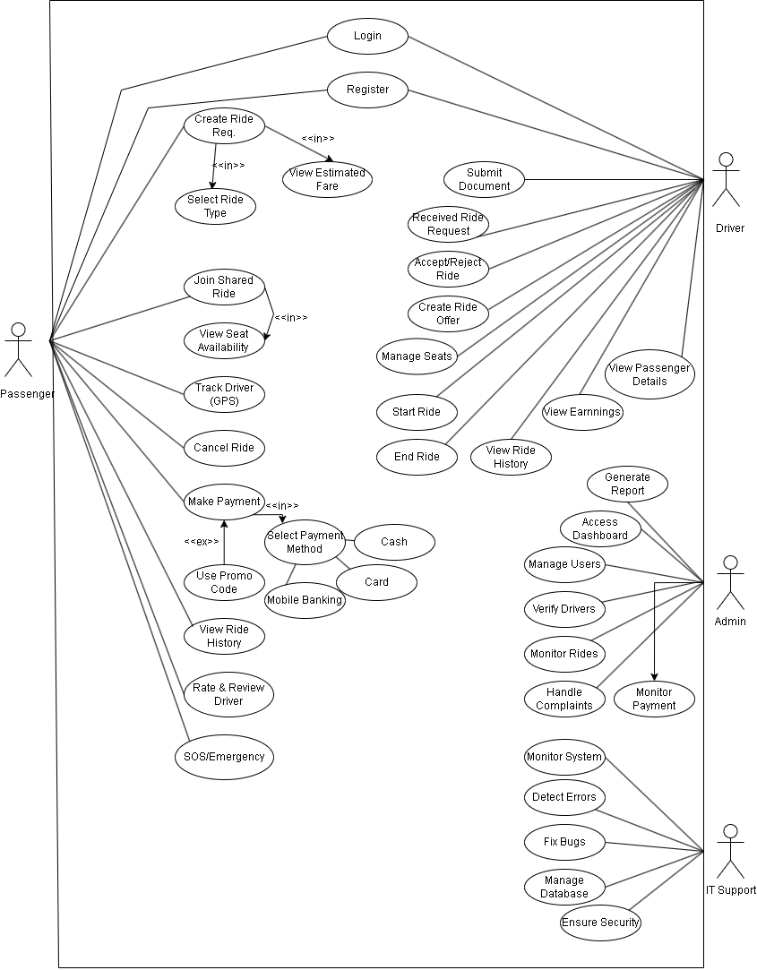
Figure 2: Use-Case Diagram

Class Diagram
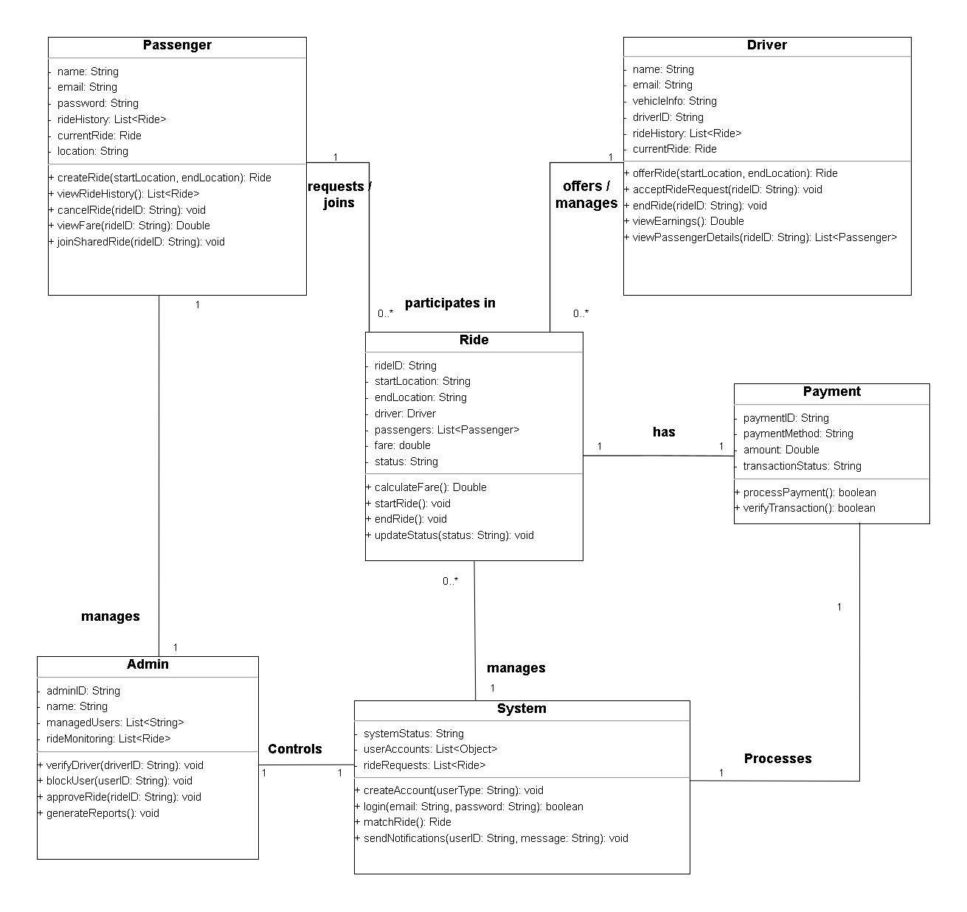

Figure 3: Activity Diagram

Wireframe Design
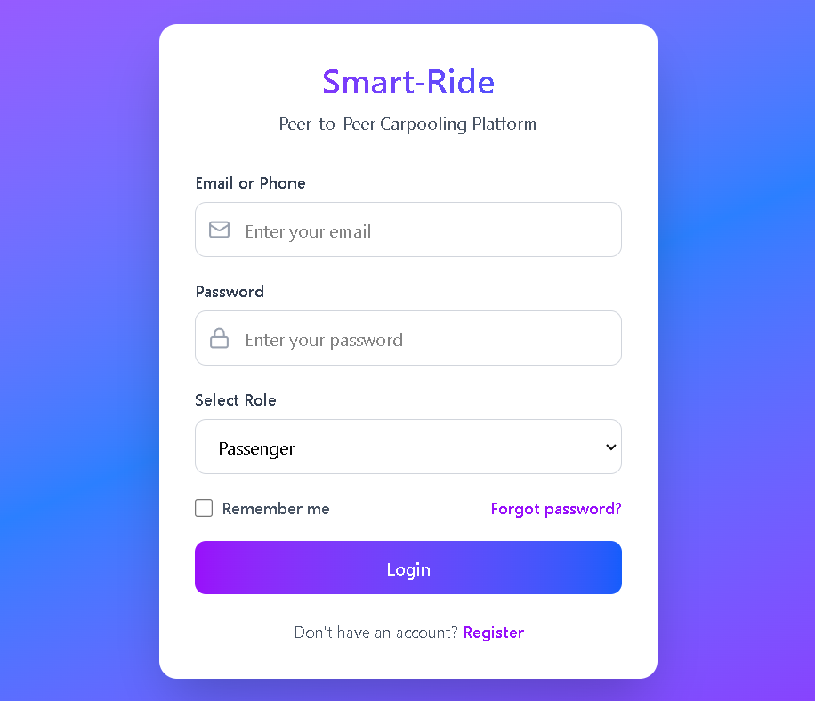
Figure 4: Login Page
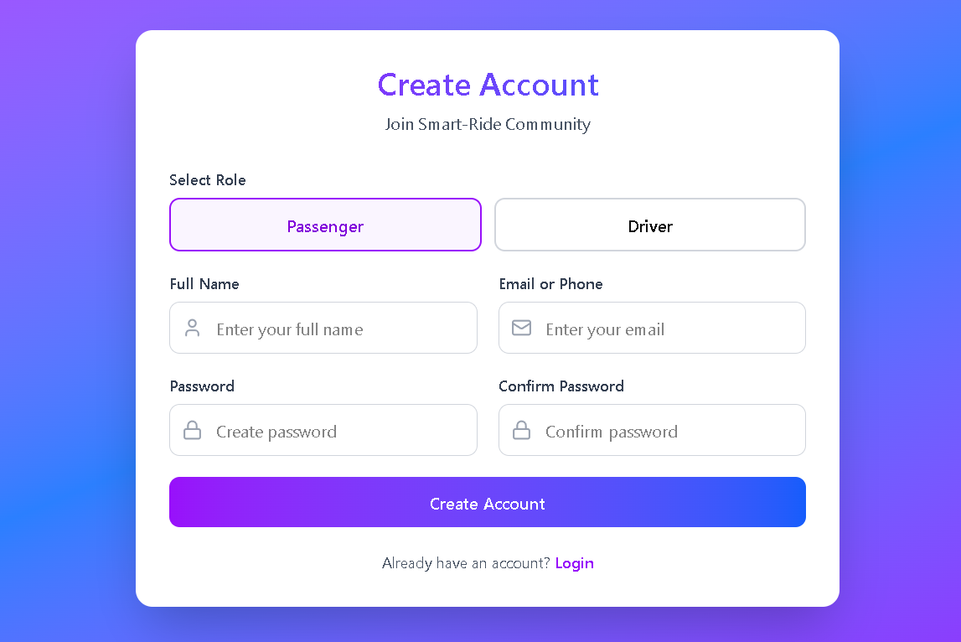
Figure 5: Registration Page

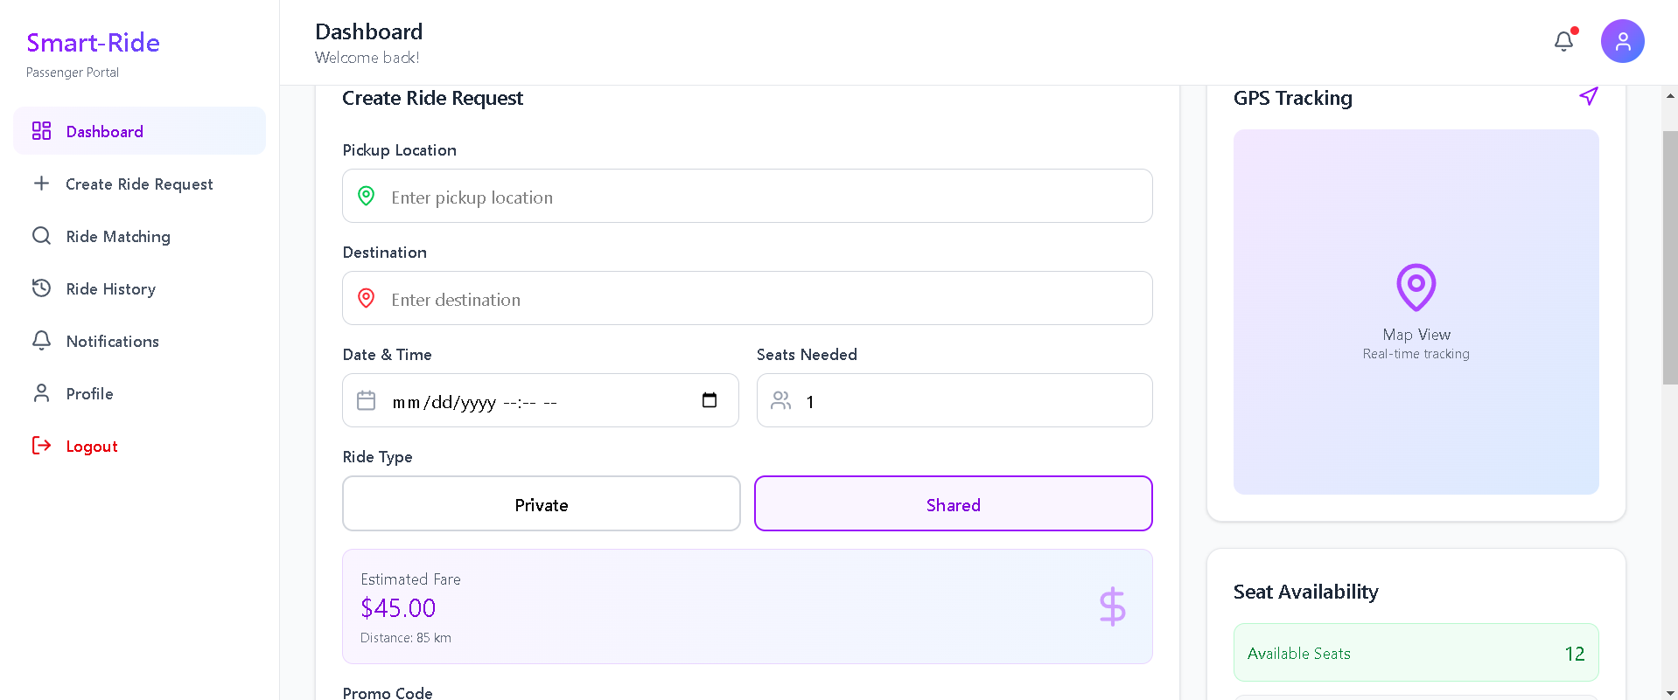
Figure 6: Passenger Dashboard
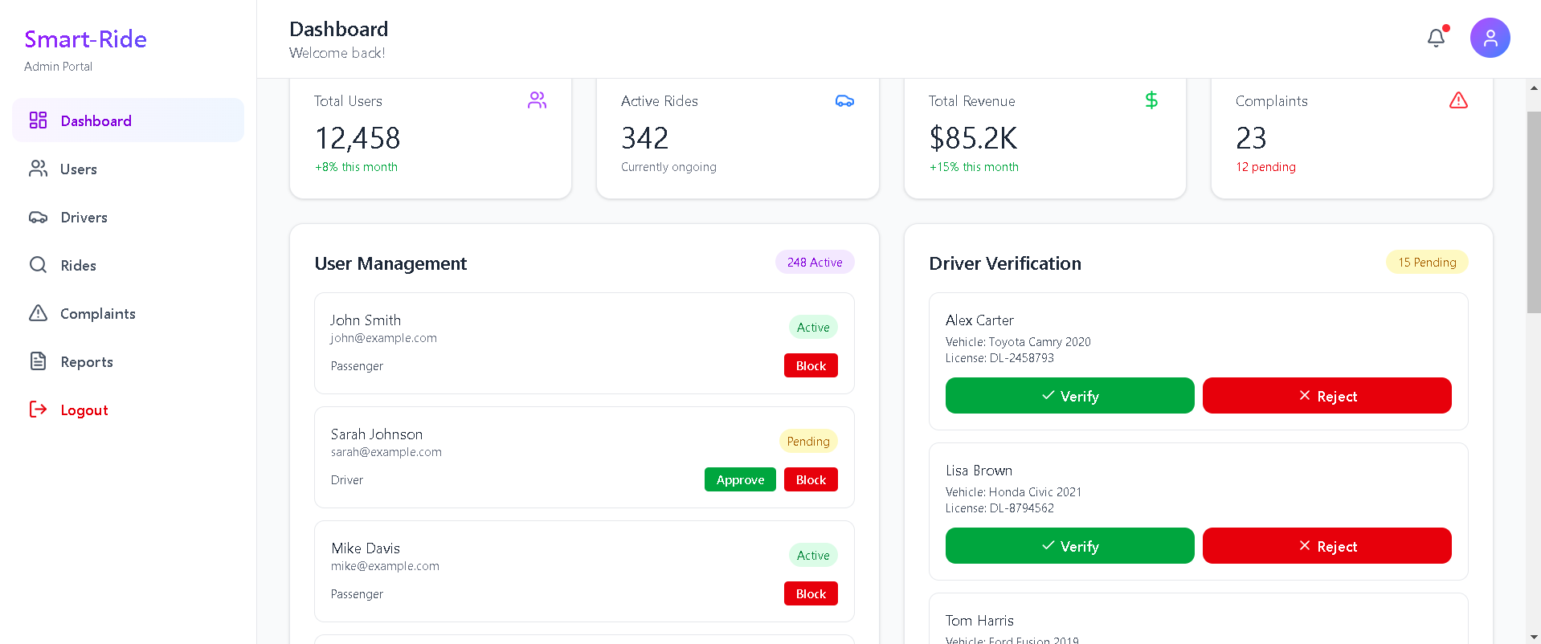
Figure 7: Admin Dashboard
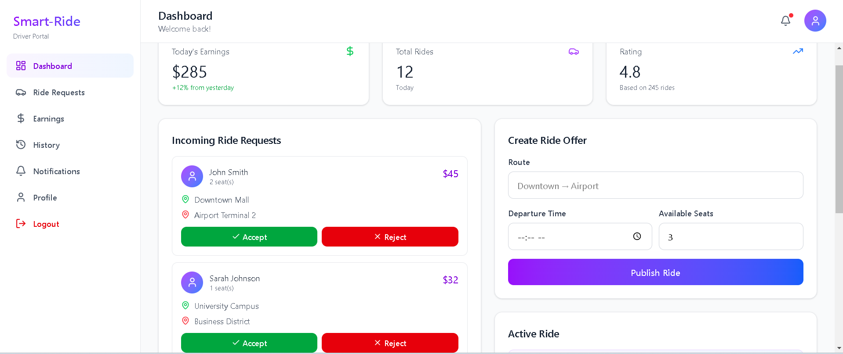
Figure 8: Driver Dashboard

GIT WORKFLOW
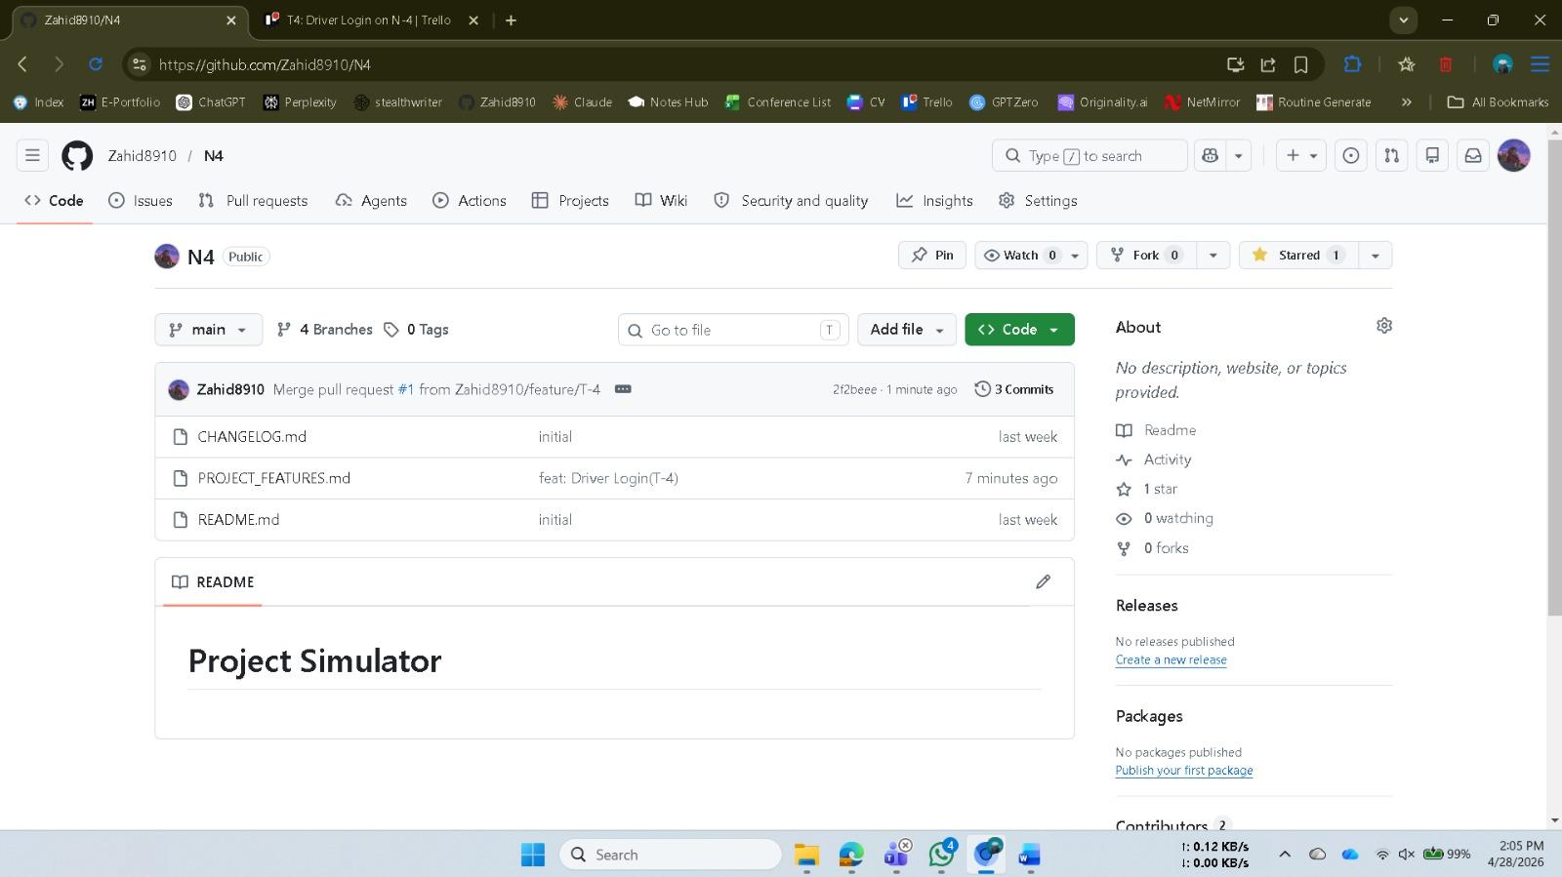
Fig 9: Mother Repository
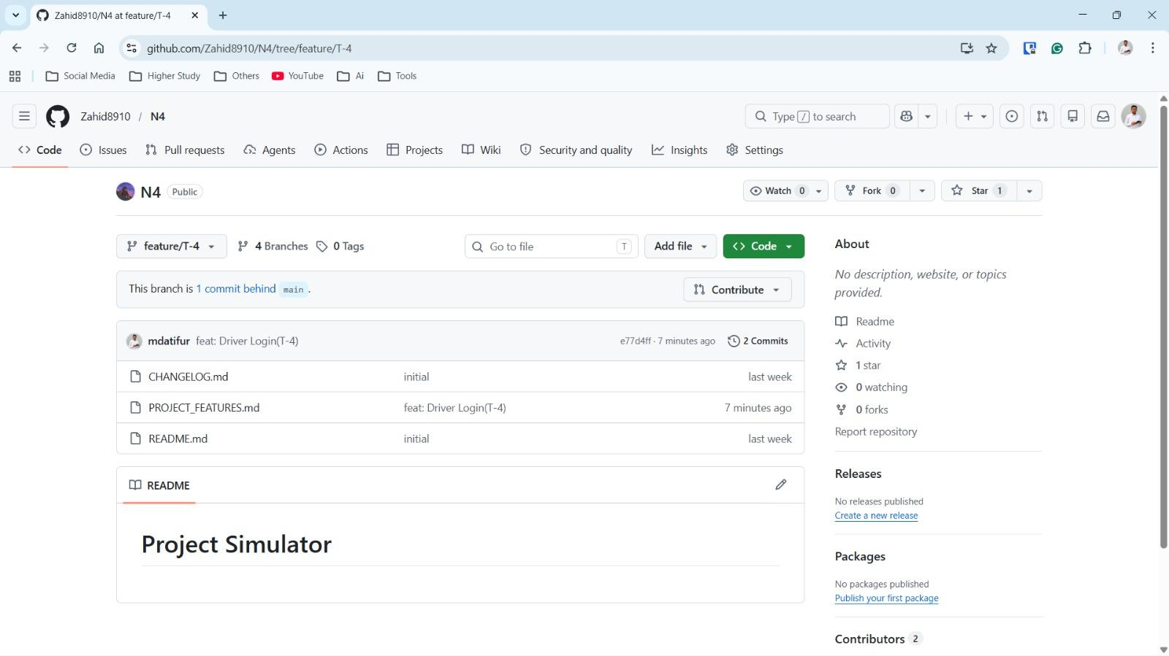
Fig 10: Feature Repository

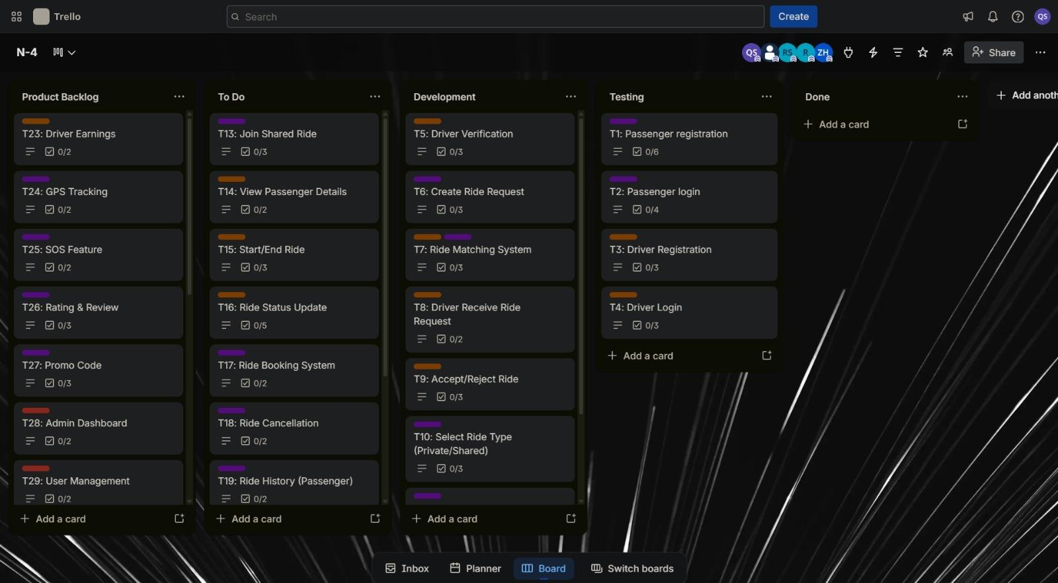

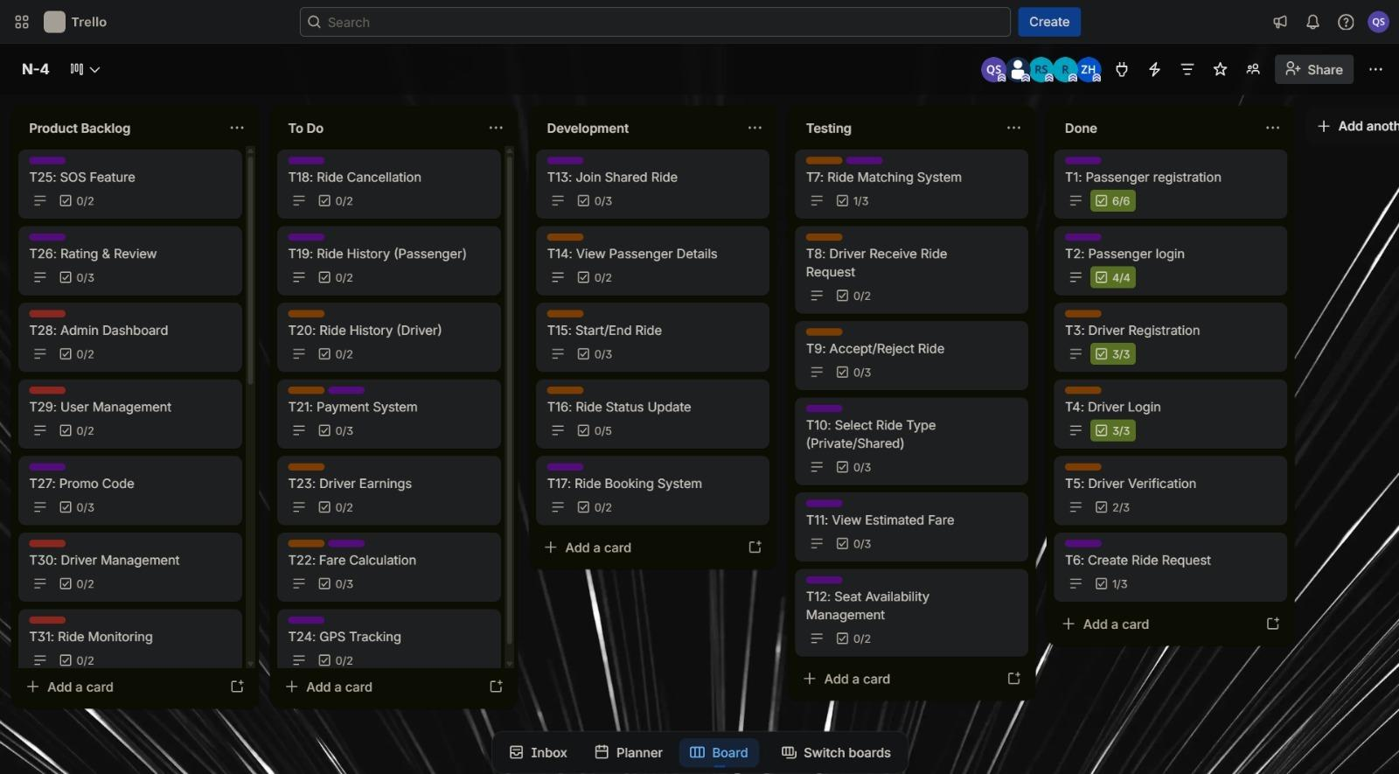

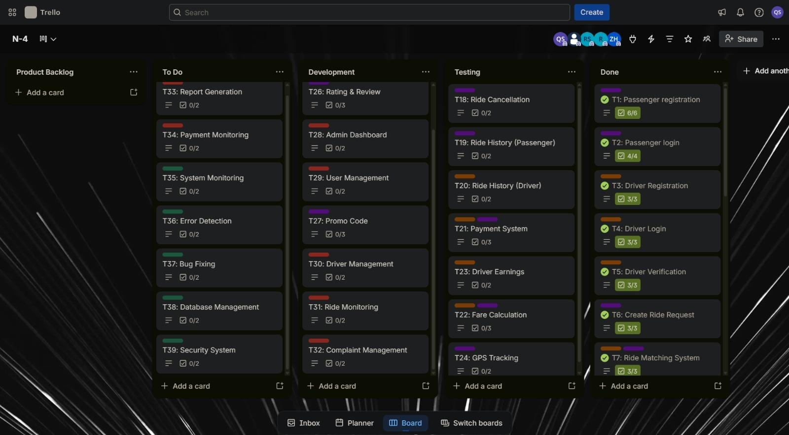

SOFTWARE TESTING
Project Name: A Peer-to-Peer Carpooling Platform for Long Distance Passengers |  |  | Test Designed by: Md. Zahid Hasan
Test Case ID: FR_1.2 |  |  | Test Designed date: 30/04/2026
Test Priority (Low, Medium, High): High |  |  | Test Executed by: Name
Module Name: Login System |  |  | Test Execution date: date
Test Title: Verify login with valid credentials
Description: Verify that the system correctly validates login credentials and prevents access when incorrect information is provided.
Precondition: User is already registered in the system.
Dependencies: Database and authentication system must be active.
Test Steps | Test Data | Expected Results |  | Actual Results | Status (Pass/Fail)
- Open login page  - Enter valid email/phone  - Enter correct password  - Click “Login” button | Correct:  Username:  zahid.hasan.8910@gmail.com  Password: zahid1234 | The user should log in to the application by providing correct information
Post Condition: User session is created and stored in database

Project Name: A Peer-to-Peer Carpooling Platform for Long Distance Passengers |  |  | Test Designed by: Quazi Saad
Test Case ID: FR_1.3.1.7 |  |  | Test Designed date: 30/04/2026
Test Priority (Low, Medium, High): High |  |  | Test Executed by: Name
Module Name: Seat Availability Management |  |  | Test Execution date: date
Test Title: Verify seat availability display and dynamic seat count update
Description: System displays available seats for shared rides and updates dynamically.
Precondition: The passenger is logged in and a shared ride with available seats exists in the system.
Dependencies: Active internet connection and updated ride/seat availability database.
Test Steps | Test Data | Expected Results |  | Actual Results | Status (Pass/Fail)
- Open available shared ride list  - Select a ride  - View available seats  - Book/confirm a seat  - Check updated seat count | Ride Type: Shared  Ride Initial  Available Seats: 3  Passenger selects 1 seat  Click “Confirm Booking” | The system should display the available seats for the selected ride.  After the passenger books 1 seat, the available seat count should decrease from 3 to 2.  The updated seat count should be shown dynamically to the passenger.
Post Condition: The booking is recorded in the database, and the available seat count is updated accordingly

Project Name: A Peer-to-Peer Carpooling Platform for Long Distance Passengers |  |  | Test Designed by: Quazi Saad
Test Case ID: FR_1.3.1.13 |  |  | Test Designed date: 30/04/2026
Test Priority (Low, Medium, High): High |  |  | Test Executed by: Name
Module Name: Payment System |  |  | Test Execution date: date
Test Title: Verify secure payment processing via multiple methods
Description: Supports payment via cash, card, or mobile banking with secure transaction handling
Precondition: The user has completed a ride booking and reached the payment interface.
Dependencies: Active internet connection, available payment gateway, and valid payment method.
Test Steps | Test Data | Expected Results |  | Actual Results | Status (Pass/Fail)
- Select method  - Process payment  - Confirm | Selected Method: Card  Card No: 4242#######  Expiry: 12/28  CVV: 123  Click "Confirm Payment" | The system should display available payment methods: cash, card, and mobile banking.  After selecting a method, the system should process the payment securely.  A “Payment Successful” or confirmation message should appear after confirmation.
Post Condition: The transaction is recorded in the database, and both the driver and passenger receive a confirmation receipt. The account balances are updated accordingly.

Project Name: A Peer-to-Peer Carpooling Platform for Long Distance Passengers |  |  | Test Designed by: Md. Zahid Hasan
Test Case ID: FR_1.4.4 |  |  | Test Designed date: 02/05/2026
Test Priority (Low, Medium, High): High |  |  | Test Executed by: Name
Module Name: Ride Booking System |  |  | Test Execution date: date
Test Title: Verify passenger can create and confirm a ride request
Description: Test the system’s ability to allow a passenger to create a ride request and proceed to booking.
Precondition: User is logged in as Passenger.
Dependencies: Ride matching system and database must be active.
Test Steps | Test Data | Expected Results |  | Actual Results | Status (Pass/Fail)
- Login as passenger  - Enter pickup location  - Enter destination  - Select ride type (Shared/Private)  - Click “Search Ride”  - Select available ride  - Click “Confirm Booking” | Pickup: Dhaka Destination: Sylhet Ride Type: Shared | System displays available rides.  Seat availability is shown. User can successfully  confirm booking.  Booking confirmation message appears.
Post Condition: Ride is successfully booked and stored in the system. User booking history is updated.

Project Name: A Peer-to-Peer Carpooling Platform for Long Distance Passengers |  |  | Test Designed by: Atifur Rahaman Shohan
Test Case ID: FR_2.3 |  |  | Test Designed date: 02/05/2026
Test Priority (Low, Medium, High): High |  |  | Test Executed by: Name
Module Name: Driver Registration System |  |  | Test Execution date: date
Test Title: Test the system ability to register a new driver with document verification.
Description: Verify that the system correctly collects driver information, vehicle details, and uploaded documents, and sends them for admin verification.
Precondition: User has a valid email/phone and is not already registered as a driver.
Dependencies: Database and document upload system must be active.
Test Steps | Test Data | Expected Results |  | Actual Results | Status (Pass/Fail)
- Open registration page  - Select role as Driver  - Enter personal information  - Enter vehicle information  - Upload driving license  - Click "Create Account"  - Wait for admin verification | Name: Rahim Uddin Phone: 017xxxxxxxxVehicle: Toyota Axio License No: 2025-001 | All fields are accepted.  Document is uploaded successfully.  Account is created with pending verification status.  Notification is sent to admin for document review.
Post Condition: Driver account is stored in database with verification pending status. Admin receives notification to verify documents.

Project Name: A Peer-to-Peer Carpooling Platform for Long Distance Passengers |  |  | Test Designed by: Md. Naimur Rahman Kayes
Test Case ID: FR_3.1.1 |  |  | Test Designed date: 11/05/2026
Test Priority (Low, Medium, High): High |  |  | Test Executed by: Name
Module Name: Admin Dashboard |  |  | Test Execution date: date
Test Title: Test the Admin Dashboard overview functionality
Description: Verify that Admin can view overall system status, users, rides, and analytics from the dashboard.
Precondition: User is logged in as Admin.
Dependencies: User management, ride monitoring, payment, and report modules must be active.
Test Steps | Test Data | Expected Results |  | Actual Results | Status (Pass/Fail)
- Log in as Admin using valid credentials  - View the Dashboard overview section  - Navigate to User Management section  - Navigate to Ride Monitoring section  - Navigate to Analytics / Report Generation | Email:admin@carpool.com Password: Admin1122  Admin account with active users, rides, and payments  Existing registered users (Passenger & Driver)  Active and completed rides in the system  Ride data, user data, transaction data | Admin is successfully authenticated and redirected to the Admin Dashboard  Dashboard displays total users, active rides, completed rides, and payment summary  List of all users is displayed with options to block/approve  All ride details (status, route, users) are shown in view-only mode  System generates and displays a report based on selected criteria
Post Condition: Admin successfully views system overview. All modules (users, rides, payments, analytics) are accessible and correctly displayed on the dashboard.

Project Name: A Peer-to-Peer Carpooling Platform for Long Distance Passengers |  |  | Test Designed by: Md. Naimur Rahman Kayes
Test Case ID: FR_3.1.2 |  |  | Test Designed date: 10/05/2026
Test Priority (Low, Medium, High): High |  |  | Test Executed by: Name
Module Name: User Management |  |  | Test Execution date: date
Test Title: Test Admin's ability to approve, block, and manage user accounts
Description: Verify that Admin can view all registered users and successfully approve, block, or manage their accounts from the Admin Dashboard.
Precondition: Admin is logged in. At least one registered Passenger and one Driver account exist in the system.
Dependencies: User registration module and admin authentication module must be active.
Test Steps | Test Data | Expected Results |  | Actual Results | Status (Pass/Fail)
- Log in as Admin and navigate to User Management section  - Search or locate a specific user (Passenger or Driver)  - Select a pending/new user account and click Approve  - Select an active user account and click Block  - Attempt to log in with the blocked user account | Email:  admin@carpool.com  Password: Admin@1122  User:  passenger01@email.com  New Driver account  awaiting approval  Active Passenger:  passenger01@email.com  Blocked user credentials | Admin is redirected to the User Management page  Selected user details are displayed correctly  Account status changes to “Approved” and access is granted  Account status changes to “Blocked” and login is restricted  System denies login with an error message
Post Condition: User account status is correctly updated in the system. Approved users gain access; blocked users are denied login. All changes are reflected in the Admin Dashboard.

Project Name: A Peer-to-Peer Carpooling Platform for Long Distance Passengers |  |  | Test Designed by: Atifur Rahaman Shohan
Test Case ID: FR_4.2 |  |  | Test Designed date: 03/05/2026
Test Priority (Low, Medium, High): High |  |  | Test Executed by: Name
Module Name: SOS / Emergency System |  |  | Test Execution date: date
Test Title: Test the SOS emergency button functionality during an active ride.
Description: Verify that pressing the SOS button during a ride sends an emergency alert to the admin and support team immediately.
Precondition: User is logged in as Passenger. A ride is currently active
Dependencies: Notification system and admin monitoring module must be active.
Test Steps | Test Data | Expected Results |  | Actual Results | Status (Pass/Fail)
- Start an active ride as passenger  - Locate the SOS/Emergency button on the screen  - Press the SOS button  - Confirm the emergency alert dialog  - Check if alert is sent | Passenger:  Active ride Location: Shared via GPS Alert Type: SOS Emergency | SOS button is visible during active ride.  Confirmation dialog appears before sending. Emergency alert is sent to admin immediately.  Passenger sees confirmation that help is on the way.
Post Condition: Emergency alert is received by admin. Ride location and passenger details are shared with support team.

CONCLUSION
The proposed Peer-to-Peer Carpooling Platform for Long-Distance Passengers is designed to solve some of the common transportation issues like high travel expenses, unfair fare distribution, lack of pricing transparency, and inefficient utilization of seats. The project was able to successfully identify real world commuting issues and convert them to structured functional and non-functional requirements using suitable software engineering practices. The system adds a smart distance-based fare calculation mechanism to enable passengers to pay fairly based on their travel distance which makes ride sharing more transparent, affordable and efficient.

The use of the Agile Scrum process model enabled the management of the project in an organized and flexible way, enabling the continual feedback, the development in sprints, and the gradual improvement of the features of the system. Different software engineering artifacts like user stories, requirement traceability matrices, system design diagrams, wireframe, Git workflow, and software testing documentation were used to support proper planning, traceability and quality assurance during the development process.

The project overall illustrates the potential of a structured carpooling platform in enhancing transportation convenience for passengers and optimizing the use of transportation devices for drivers. The proposed system is promising in the practical implementations in modern urban transportation environments.

